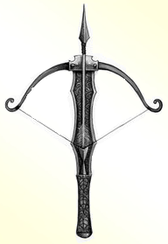 Elven Crossbow

Upon dropping an opponent to 0 hp, the foe is polymorphed into a raven with no memories of their previous life. Their possessions fall onto the floor. The raven attempts to fly away as soon as possible.

Value: 500 gold